

NATIONAL INSTITUTE OF TECHNOLOGY KARNATAKA

SURATHKAL, MANGALORE - 575 025

Course Code – CS254

Course Name – Database Systems Lab

Lab - 01

Date – January 27, 2022

Submitted To

Dr. Annappa B

Department of Computer Science and Engineering

National Institute of Technology Karnataka, Surathkal

Submitted By

Md Rakib Hasan

Roll – 201CS132

Department of Computer Science and Engineering

**1. Write SQL statements for:**

Create a table flights with the following information:

FLIGHT(flno, fromplace, toplace, distance, departs, arrives)

**a.** **Inserting data into the flight with five entries.**

USE one_finfo;

CREATE TABLE flight (

    flno INT(5),

    fromplace VARCHAR(50),

    toplace VARCHAR(50),

    distamce INT(5),

    departs DATETIME,

    arrives DATETIME);

INSERT INTO flight

     VALUES (444, 'Dhaka', 'Kolkata', 1000,

     '2022:01:06 00:05:01', '2022:01:06 00:06:00'),

     (424, 'Kolkata', 'Bengalore', 2500,

     '2022:01:06 00:10:01', '2022:01:07 00:00:05'),

     (104, 'Bengalore', 'Mangalore', 500,

     '2022:01:07 10:00:01', '2022:01:08 00:00:05'),

     (044, 'Kolkata', 'Chennai', 5000,

     '2022:01:22 00:05:01', '2022:01:23 00:06:00'),

     (001, 'Delhi', 'Bengalore', 5001,

     '2022:01:01 00:05:01', '2022:01:01 00:06:00');

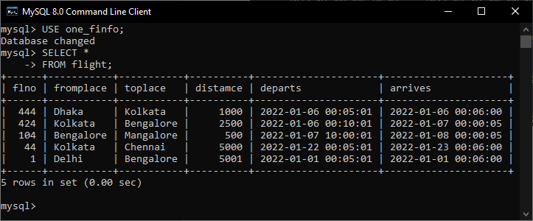

**b. Altering table by adding new column price.**

ALTER TABLE flight

    ADD price INT(5);

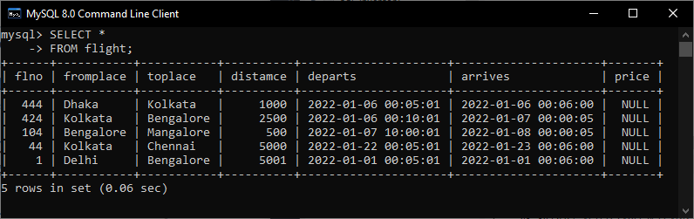

**c. Deleting a row from the table.**

DELETE FROM flight

    WHERE flno = 44

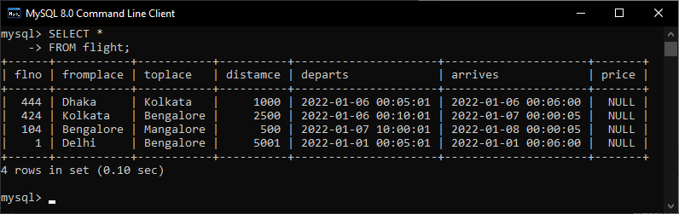

**d. Drop column distance.**

ALTER TABLE flight

    DROP COLUMN distamce;

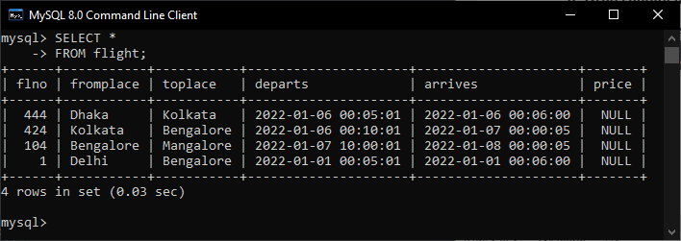

**e. Enter any one row with a price value accepting the NULL value then update it to a particular price.**

INSERT INTO flight(flno, fromplace, toplace,

    departs, arrives)

VALUES (101, 'A', 'B',

    '2022:01:11 00:01:00', '2022:01:12 00:02:00');

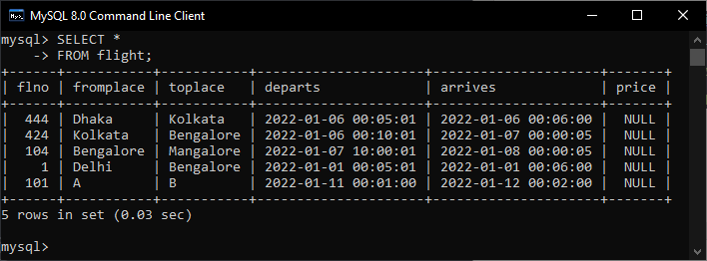

UPDATE flight

SET price = 1500

WHERE flno = 101

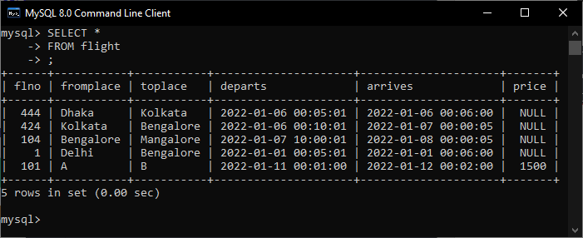

**f. Delete all the data from the table.**

DELETE FROM flight;

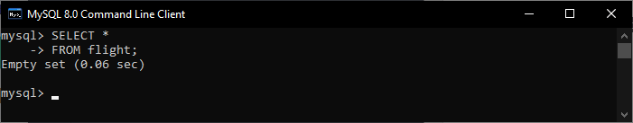

**g. Rename a column price to journey_price.**

ALTER TABLE flight

RENAME COLUMN price TO journey_price;

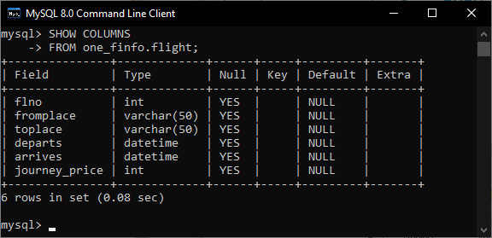

**2. Consider the following schema for a Library Database.**

BOOK (Book_id, Title, Publisher_name, Pub_year)

BOOK_AUTHORS (Book_id, Author_name)

PUBLISHER (Book_id, Name, Address, Phone)

CREATE DATABASE IF NOT EXISTS one_library;

USE one_library;

CREATE TABLE book (

    book_id INT NOT NULL ,

    title VARCHAR(50),

    publisher_name VARCHAR(50),

    pub_year DATE,

    PRIMARY KEY (book_id));

CREATE TABLE book_authors (

    book_id INT,

    author_name VARCHAR(50),

    FOREIGN KEY (book_id) REFERENCES book(book_id));

CREATE TABLE publisher (

    book_id INT,

    name  VARCHAR(50),

    address VARCHAR(100),

    phone INT,

    FOREIGN KEY (book_id) REFERENCES book(book_id));

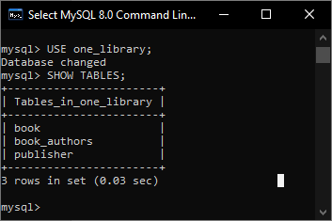

**a. Enter at least five tuples for the given relation.**

INSERT INTO book

    VALUES (100, 'Book One', 'Publisher one', '2012-01-01'),

    (101, 'Book Two', 'Publisher Two', '2015-01-01'),

    (102, 'Book Three', 'Publisher Three', '2009-01-01'),

    (103, 'Book Four', 'Publisher Four', '2011-01-01'),

    (104, 'Book Five', 'Publisher Five', '2010-01-01');

INSERT INTO book_authors

    VALUES (101, 'Author A'),

    (102, 'Author B'),

    (103, 'Author C'),

    (104, 'Author D'),

    (100, 'Author E');

INSERT INTO publisher

    VALUES (100, 'P one', 'Address one', 123456789),

        (101, 'P two', 'Address two', 123456799),

        (102, 'P three', 'Address three', 123056789),

        (103, 'P four', 'Address four', 123451789),

        (104, 'P five', 'Address five', 123454789);

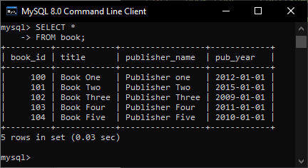 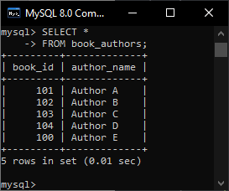 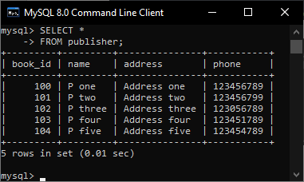

**b. Retrieve details of all books in the library – id, title, name of the publisher, author, etc.**

USE one_library;

SELECT *

FROM book

JOIN book_authors

    USING (book_id)

JOIN publisher

    USING (book_id);

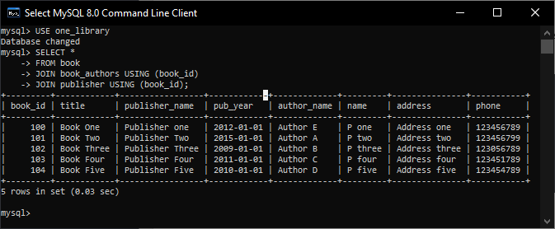

**c. Get the books written by a particular author.**

SELECT *

FROM book_authors

JOIN book

    USING (book_id)

WHERE author_name = 'Author E';

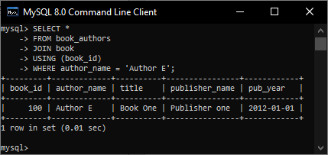

**d. Delete a book from the book table.**

DELETE FROM book

WHERE book_id = 100

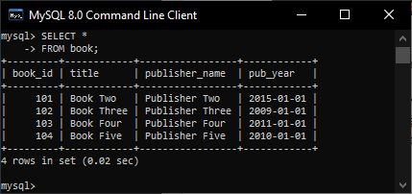

**e. Update the phone number of a publisher.**

UPDATE publisher

SET phone = 123

WHERE book_id = 101

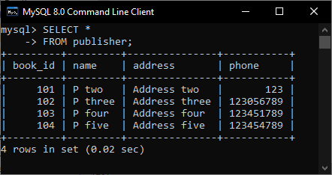

**f. Through book_id retrieve the details of author name and publisher details.**

SELECT *

FROM book_authors

JOIN publisher p

    USING (book_id)

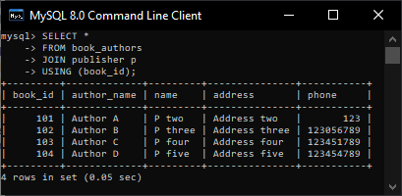

**g. Drop author_name column from Book_authors.**

ALTER TABLE book_authors

DROP COLUMN author_name

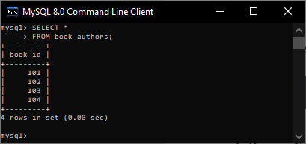

**h. Rename Name (from publisher) to Publisher_name.**

ALTER TABLE publisher

RENAME COLUMN name TO publisher_name

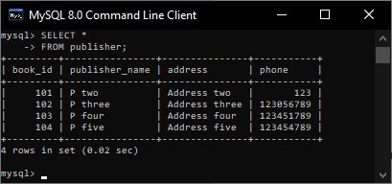

**3. Consider the following schema for OrderDatabase:**

**SALESMAN (Salesman_id, Name, City, Salary)**

**CUSTOMER (Customer_id, cust_Name, City, Salesman_id)**

**ORDERS (Ord_No, Purchase_Amt, Ord_Date, Customer_id, Salesman_id)**

**Write SQL queries to –**

CREATE DATABASE one_orderdatabase;

USE one_orderdatabase;

CREATE TABLE salesman (

    salesman_id INT NOT NULL,

    name VARCHAR(50),

    city VARCHAR(100),

    salary INT,

    PRIMARY KEY (salesman_id));

CREATE TABLE customer (

    customer_id INT NOT NULL,

    cust_name VARCHAR(50),

    city VARCHAR(50),

    salesman_id INT NOT NULL,

    PRIMARY KEY (customer_id),

    FOREIGN KEY (salesman_id) REFERENCES

    salesman(salesman_id)

    ON DELETE CASCADE

    ON UPDATE CASCADE);

CREATE TABLE orders (

    ord_no INT NOT NULL,

    purchase_amt INT,

    ord_date DATE,

    customer_id INT NOT NULL,

    salesman_id INT NOT NULL,

    PRIMARY KEY (ord_no),

    FOREIGN KEY (customer_id) REFERENCES

    customer(customer_id)

    ON DELETE CASCADE

    ON UPDATE CASCADE,

    FOREIGN KEY (salesman_id) REFERENCES

    salesman(salesman_id)

    ON DELETE CASCADE

    ON UPDATE CASCADE);

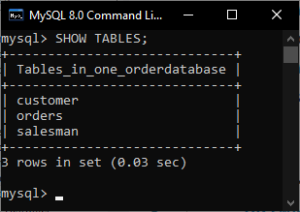

**a. Insert 5-10 entries.**

INSERT INTO salesman

    VALUES (101, 'Salesman A', 'City 1A', 1000),

    (102, 'Salesman B', 'City 1B', 1001),

    (103, 'Salesman C', 'City 1C', 1002),

    (104, 'Salesman D', 'City 1D', 1003),

    (105, 'Salesman E', 'City 1E', 1004);

INSERT INTO customer

    VALUES (201, 'Customer A', 'City 2A', 101),

    (202, 'Customer B', 'City 2B', 102),

    (203, 'Customer C', 'City 2C', 103),

    (204, 'Customer D', 'City 2D', 104),

    (205, 'Customer E', 'City 2E', 105);

INSERT INTO orders

    VALUES (301, 123, '2022-01-02', 201, 101),

    (302, 124, '2022-01-03', 202, 102),

    (303, 125, '2022-01-04', 203, 103),

    (304, 126, '2022-01-05', 204, 104),

    (305, 127, '2022-01-06', 205, 105);

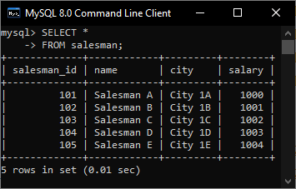 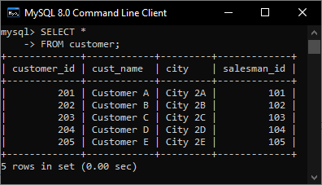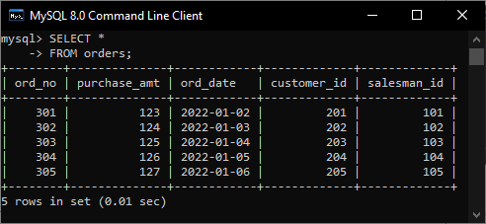

**b. Retrieve the details of all the customers and orders.**

SELECT *

FROM customer

JOIN orders

    USING (customer_id)

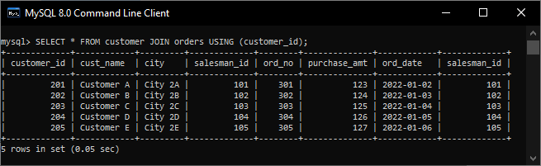

**c. Get the customers handled by a particular salesman.**

SELECT s.name,

    c.cust_name as customer

FROM salesman s

JOIN customer c

    USING (salesman_id)

WHERE salesman_id = 105

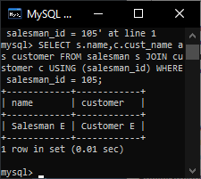

**d. Get the details of orders purchased by customers.**

SELECT c.cust_name,

    o.purchase_amt AS price,

    o.ord_date AS date

FROM customer c

JOIN orders o

    USING (customer_id)

WHERE cust_name = 'Customer C'

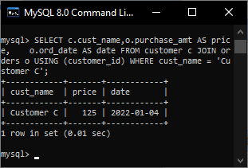

**e. Through salesman_id retrieve the details of his sold orders.**

SELECT s.name AS saller,

       c.cust_name AS customer,

       o.ord_no, o.ord_date,

       o.purchase_amt

FROM salesman s

JOIN orders o

    USING (salesman_id)

JOIN customer c

    USING (customer_id)

WHERE s.salesman_id = 103

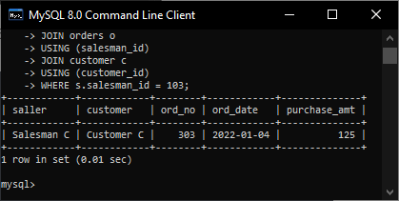

**f. One of the salesmen is getting a rise of 2000 and is getting relocated to Delhi. Update his data.**

UPDATE salesman

SET salary = salary + 2000, city = 'Delhi'

WHERE salesman_id = 101

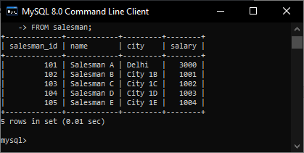

**g. Delete an order and its details as the customer placed an order and canceled it.**

DELETE

FROM orders

WHERE ord_no = 301

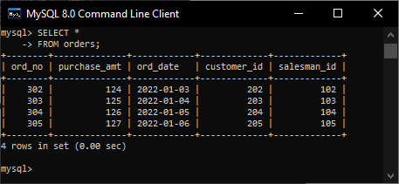

**h. Rename the City column to Place.**

ALTER TABLE customer

RENAME COLUMN city TO place;

ALTER TABLE salesman

RENAME COLUMN city TO place;

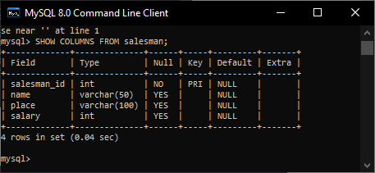

**i. Drop purchase_amt column from the table orders.**

ALTER TABLE orders

DROP COLUMN purchase_amt

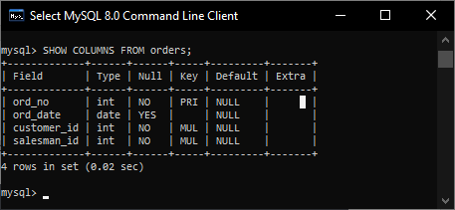

**j. Drop the table salesman.**

SET FOREIGN_KEY_CHECKS = 0;

DROP TABLE salesman;

SET FOREIGN_KEY_CHECKS = 1;

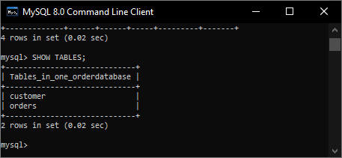

**4. Write SQL statements for the following.**

**Create a table sub with the following information: column and data types: name varchar(8), age number(5), mark1 number(4), mark2 number(4), mark3 number(4);**

CREATE DATABASE one_uni;

USE one_uni;

CREATE TABLE sub (

    name VARCHAR(8),

    age INT NOT NULL,

    mark1 INT,

    mark2 INT,

    mark3 INT);

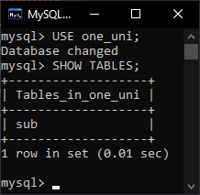

**a. Enter at least five tuples for the given relation.**

INSERT INTO sub

    VALUES ('Name A', 10, 1, 2, 3),

    ('Name B', 11, 2, 3, 1),

    ('Name C', 10, 2, 1, 3),

    ('Name D', 9, 3, 1, 2),

    ('Name E', 12, 3, 2, 1);

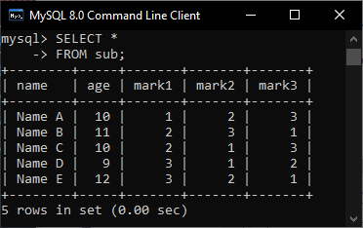

**b. Add one more column with the field name as total with data type as number(5).**

ALTER TABLE sub

ADD total INT;

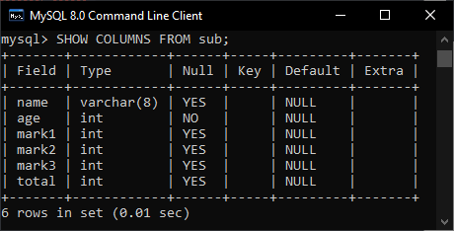

**c. Update the age of sub for a particular student.**

UPDATE sub

SET age = 9

WHERE name = 'Name A'

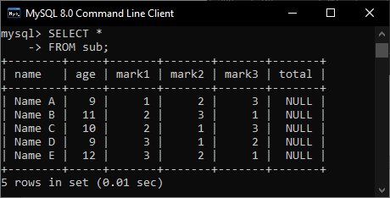

**d. Delete a row from the table.**

DELETE

FROM sub

WHERE name = 'Name A'

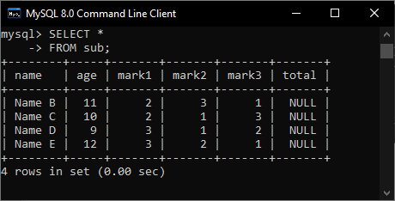

**e. Drop column mark3.**

ALTER TABLE sub

DROP COLUMN mark3

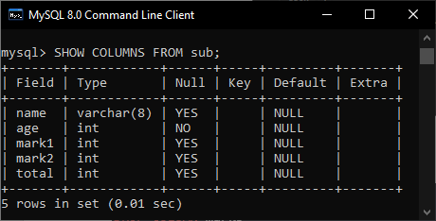

**f. Modify the table by changing the data type of name to varchar(10).**

ALTER TABLE sub

MODIFY COLUMN name VARCHAR(10)

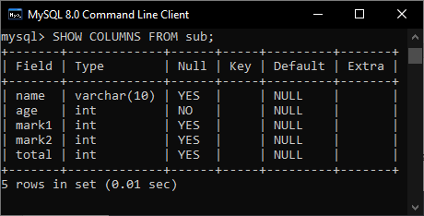

**g. Delete all the data from the sub table.**

DELETE FROM sub;

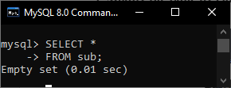

**h. Delete the table.**

DROP table sub

